Sample Puzzles
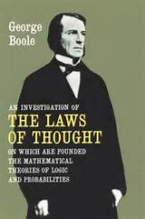
Puzzle One:
George Boole’s house has been burgled. The first copy of An Investigation of the Laws of Thought has been stolen containing all Professor Boole’s notes. The police move swiftly and capture 5 known thieves in the area, but they are not giving much away. Below you will find their statements. Can you help the police to recover Boole’s opus magnum?

David: it wasn't Philip, it was Stephanie.
Stephanie: it wasn't Olan, it wasn't Philip
Olan: it was Philip, it wasn't David
Jason: it was Olan, it was Stephanie
Philip: it was Jason, it wasn't David
It was well known that each suspect told exactly one lie.
Can you determine who stole the book?
Solution:
Olan committed the terrible crime.
Look at Stephanie’s statements, one of the statements was a lie and the other was the truth. This means that is must have been either Olan or Philip.
Examining Jason’s statements we can conclude that one is true and one is false. Olan and Stephanie are now in the frame.
Olan is the guilty one- check this against all other statements remembering that each suspect told exactly one lie each and you will be convinced of Olan’s guilt.
Hint:
Look at David’s Statements First.

Puzzle 2:

When George Boole became the first professor of mathematics in University College Cork in 1849 the college was a much smaller place than it is today. What is now the centre of the university is called the Main Quadrangle, or the Quad for short, was the whole university. As you look at it the building that faces you is called the North Wing, on your left is the West Wing and on your right, the East Wing. In a recent challenge 9 students were assigned a special study place in this historic building. There are two floors and a basement in each wing and one room on each floor has been allocated for the students. Mark, one of the lucky students to get a study space, was told to allocate the study rooms. He made detailed notes as to where each student should go but spilled a cup of coffee over his notebook. The following notes are all that he is left with. Help him to check to see that the rom are all allocated properly.
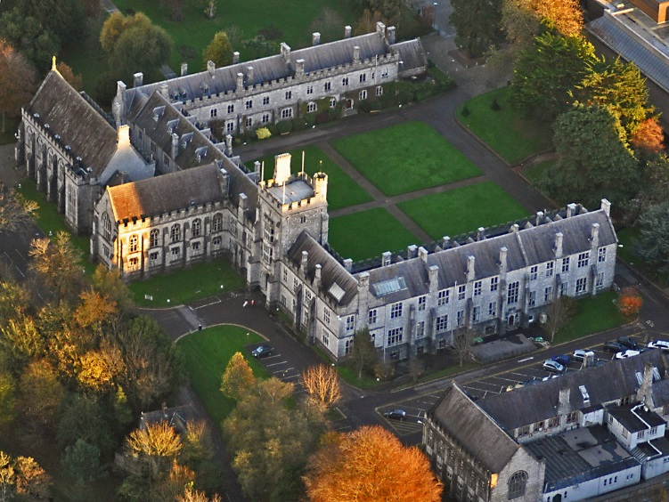
- Joe does not live on the bottom floor.
- Harry lives directly above John and directly next to Owen (who lives in the West wing).
- Tom lives in the East wing and one floor higher than Harry.
- Kevin lives directly above Harry.
- Michael lives directly above Denis

Solution
Starting with clue 2 we know Harry must live on either the top or middle floor of the north wing because he has to be next to the west wing. Clue 4 tells us Kevin lives above Harry so we know Kevin must be the top, Harry the middle and John the bottom of the north wing.
The Main Quadrangle
West | North | East
 | Kevin
 | Harry
 | John

From clue 2 we know Owen lives in the middle floor of the West Wing.
The Main Quadrangle
West | North | East
 | Kevin
Owen | Harry
 | John
Clue 3 Tome lives on the top floor of the East Wing
The Main Quadrangle
West | North | East
 | Kevin | Tom
Owen | Harry
 | John
Clue 5 Michael and Denis must live on the middle and bottom floors of the East Wing with Michael above Denis
The Main Quadrangle
West | North | East
 | Kevin | Tom
Owen | Harry | Michael
 | John | Denis
Using clue 1, we know Joe must live on the top of the west wing, leaving Mark to live at the bottom.
The Main Quadrangle
West | North | East
Joe | Kevin | Tom
Owen | Harry | Michael
Mark | John | Denis

Puzzle 3
The local golf club was buzzing with excitement this was it, the final night of the tournament. All the young people from the area gathered around to see who was going to be crowned the local champion. Robert was asked to keep the score but Robert like to take shorthand that even he could not read back at times. The tournament only had four female contestants left and only two rounds were to be played.
At the club house Robert attempted to work out the scores but this is what he had recorded.
Patricia beat Jane in both rounds.
Mary beat Linda in both rounds.
The winner in game 1 came second in game 2.
Mary won game 2 and Linda beat Jane in game 1.
No player got the same placing twice.

Can you work out who finished where in each game?

Solution
From clue 4 we know Mark won game 2
Name | Round One | Round 2
Patricia
Mary |  | 1
Linda
Jane

From clue 1 and 2, if mark beat luke in both rounds Luke can’t have come 1st in round one and if Matthew beat John in both rounds John couldn’t have come first in round one. From clue 5, no player can come 1st twice so Mark can’t have come first. Therefore Matthew came 1st in round 1.
Name | Round One | Round 2
Patricia | 1
Mary |  | 1
Linda
Jane

From clue 3, Matthew, the winner of round 1, must have come second in round 2.
Name | Round One | Round 2
Patricia | 1 | 2
Mary |  | 1
Linda
Jane

From clue 4 we know Luke beat John in round 1, so Luke had to come in either 2nd or 3rd place. But from clue 2 we know Luke lost to Mark so Luke must be 3rd, Mark 2nd and John 4th.
Name | Round One | Round 2
Patricia | 1 | 2
Mary | 2 | 1
Linda | 3
Jane | 4

From clue 5, no player can come in the same place twice so the final solution is
Name | Round One | Round 2
Patricia | 1 | 2
Mary | 2 | 1
Linda | 3 | 4
Jane | 4 | 3

Puzzle 4

At the recent gaming competition the final four took their places in the hope of topping the table. There was a wide spread in ages from young teenagers to those who had passed their 21st birthday. The ages of the contestants were 14, 17, 20 and 22.
As it happens the person who came last was the oldest, whereas Philip was three years older than the person who came second.
James was neither the oldest nor the youngest and Robin finished ahead of the 17 year old, but didn't win.vJane was also unlucky this time and didn't win either.
Can you determine who finished where and how old they are?

Solution

From clue 1 we know the 22 year old came in fourth place.
Position | Name | Age
1
2
3
4 |  | 22

From clue 2 we know Rob finished in second place as he didn’t win but still came ahead of the 17 year old. The 17 year old must have come in third place.
Position | Name | Age
1
2 | Robin
3 |  | 17
4 |  | 22

From clue 1, Philip was 2 years older than the person who came second and since the person who came second isn’t the 17 year old they must be the 14 year old, making Philip the 17 year old.
Position | Name | Age
1
2 | Robin | 14
3 | Philip | 17
4 |  | 22

From clue 4, John didn’t win. Leaving the following solution.
Position | Name | Age
1 | James | 20
2 | Robin | 14
3 | Philip | 17
4 | Jane | 22

